November 2023
Dear Pastors, Friends, and Faithful Supporters,
Thank you for praying for us and partnering with us so we can continue working in Japan.
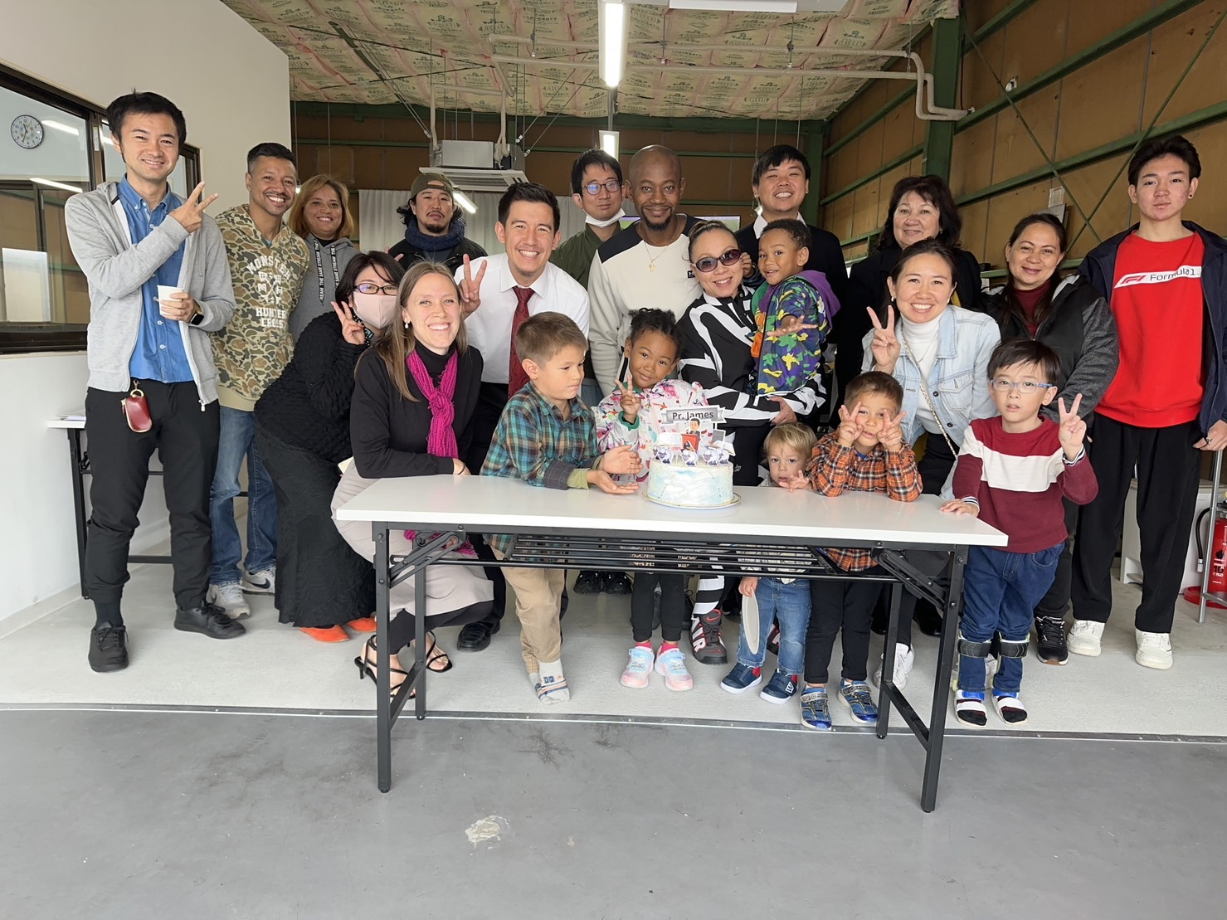
The cold winter air has moved into Nagoya. We are finding ourselves pulling out the sweaters and enjoying the warm drinks. Here are a few things that have been going on.
Our average weekly attendance has dropped somewhat compared to the same time last year. However, the number of people who are involved in working through discipleship material to help solidify their faith is at an all-time high. We go over topics such as assurance of salvation, assurance of answered prayer, etc.
and believe this time will help create a good foundation for the months and years
ahead.
James turned 30 this month. One of the ladies
who regularly comes invited a number of people who have previously come to church before to be part of the birthday celebration after the service
During this time, we are preparing for our upcoming kids program in January. Would you pray that God will use this to help us reach the community around the church? We are working to lay some foundations with our volunteers and promote the kids program. Presently, we are planning on doing it twice a month on Sunday afternoons. The flyers have started to go out and we have also been promoting on social media as well.
There are several people who have continued to attend on Sunday mornings but have not professed faith in Christ yet. Please pray that as we preach from the Gospel of John that Jesus is the Christ, the Holy Spirit will convict and work.
Finally, Spring Recon is coming up soon (March of 2024). We have limited slots available, so if you or someone you know is praying about ministry in general or Japan specifically, please be sure to register at reachingjapan.com/recon.
Yours for Japan,
The Miyashita Family
Now accepting applications for
Spring/Summer 2024

